HESSED’ CONNECTORS IN THE COMMUNITY
BY RIVKAH LAMBERT ADLER
Jerusalem Post / In jeruslaem

JULY 21, 2017 21:14

On the bank of the Danube, the river that runs through the center of Budapest, Bina had a vision she didn’t understand, whose words, directed to God, were, “I want to build You a house.”
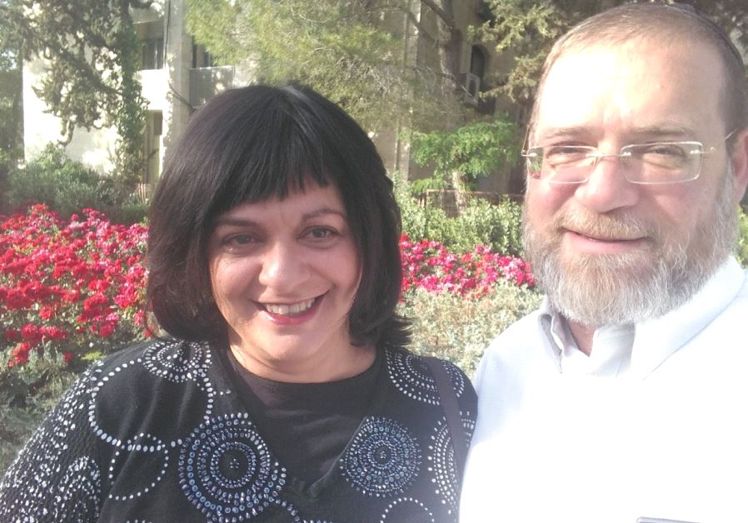
Rabbi Aaron David and Bina Poston. (photo credit:PR)
Rabbi Aaron and Bina Poston are like the biblical Abraham and Sarah of Baka. The vision for Yiboneh, the Jerusalem-based nonprofit organization they started, came from Bina. Born to a Hindu family from Jamaica, with roots in India and Persia, Bina, who lived in the United States at the time, visited Budapest in 1995.
In Budapest, she attended an International Expo. “I stumbled across a booth that I did not know was Israel,” she tells In Jerusalem. “There were pictures of Jewish images. And I had a very strong emotional reaction. A very strong reaction. It was a reaction that for me was inexplicable.
That was my first initiation.”
On the bank of the Danube, the river that runs through the center of Budapest, Bina had a vision she didn’t understand, whose words, directed to God, were, “I want to build You a house.” It wasn’t until many years later that she recalled the vision at the Danube. When it came back to her, she knew she and her husband needed to start Yiboneh.
Her husband Aaron, today an Orthodox rabbi, was raised a proud Reform Jew. “I was a bleeding-heart liberal. I felt bad for the Palestinians. I married a non-Jew,” he says. Dissatisfied with what he perceived as a lack in his spiritual life, he went searching all over for his spiritual home. He became a bornagain Christian and was ordained as a minister of his own church. Among his pursuits, he explored Gnosticism, learned from Essenes and studied Christianity of the Far East.
“I picked up pieces that I thought were truth,” he recalls. At 23, after meeting his first Orthodox Jew, he divorced his non-Jewish wife and came to Israel to study at Aish HaTorah. As a result of exploring so many other faith traditions, Poston was interested in anti-missionary work. First, he “made a commitment to learn for 10 years before going out to do anti-missionary work.” Ultimately, he spent 20 years immersing himself in Torah studies.
Bina and Aaron met at Shir Hadash in Katamon and were married in 2009. In November 2015, Bina told Aaron about her vision at the Danube 20 years earlier, and the idea to build something in their Jerusalem neighborhood was born.
The organization’s original goal was to help prepare the Jewish people for the Messianic era, which the Postons believe is fast approaching. “So many people are not connected to their Jewish roots. They come to Israel for all kinds of reasons. Yet, the more we’re connected to our Jewish roots, the more prepared we are.”
Yiboneh started with a two-pronged approach. They offered Torah classes in English and opportunities to do practical, hands-on hessed (voluntary acts of kindness). The Postons emphasize that participants do not have to be religious to participate. In fact, at nearly every Yiboneh event, a percentage of the crowd are adult Jewish beginners. As a natural extension of its work building “unity in the community,” Yiboneh also sponsors multiple social events around Shabbat and Jewish holidays.
The classes that Yiboneh sponsors are geared toward “helping people become better people. That’s the theme for most speakers,” Rabbi Poston explained.
Aware that new immigrants might feel isolated, Yiboneh offers a range of options at different times of day. Besides evening classes with an array of guest speakers, Poston holds a “Lunch and Learn” two days a week at Hineni Jerusalem.
There are bi-weekly morning classes for men, afternoon classes for men and women and evening classes on Mondays and Thursdays.
The groups of learners are diverse.
Some are older. Some are busy trying to make a living. Some are newly religious.
Some have been religious for years.
“Even some people who don’t believe in God or the Bible come,” Poston says.
In addition to Torah classes, another emphasis of Yiboneh is hessed. “Hessed is one of the three classic characteristics of every Jewish person. When a Jew does hessed, there’s a good chance that it will resonate with the soul of that person.
Hessed can connect people,” he says.
The Postons also deal with crisis situations in their community – people who are struggling emotionally or spiritually, including those who are having a hard time in Israel. “We want people to stay here,” Rabbi Poston elaborated.
“They have a hard time with Jewish culture and they’re struggling on all levels. They might want to give up.
We’re there for them. We have them over for Shabbat. We introduce them to others at our Shabbat table.” The couple does outreach to converts as well, serving as adoptive families for prospective converts.
“Olam hessed yiboneh – the world is built with kindness. We think of ourselves as hessed connectors in the community.
We are working our corner of the world, to help the Jewish people build merit,” Bina said.
There are a handful of people who support the work of Yiboneh, but the Postons are “always looking for new sponsors. We’re grateful for what we have, but we need more support. We have not taken a salary since we started.
Expenses for speakers, rent, food and guests for Shabbat are covered partially by entrance fees.”
Typically, 25 to 30 people show up to for each guest lecture, but hundreds from all over the world will watch it later. On Rabbi Poston’s wish list is better equipment to record classes that he posts to Yiboneh’s YouTube channel.
Based on emails received, Yiboneh classes are even reaching non-Jews in countries such as Turkey, Malaysia, Singapore, the Philippines and Nigeria.
Currently working as a private caregiver for the elderly and terminally ill, Bina’s goal is to have time to create more inspirational opportunities for women and to mentor them in building a Jewish home. She wants to provide women in their community with tools to invest in their marriages and help single people who are having trouble finding partners.
More support would also give her time to add additional hessed projects to Yiboneh’s offerings.
Both Postons agree that their vision is “to stay local and build relationships.
We work with all the shuls and the rabbis.
While a physical center for learning would be great, a global village means we can reach more people,” Rabbi Poston says.
While it’s intriguing to know their programs are reaching people all over the world, they most want to work with olim who want to understand their Jewish identities better. Their target audience is, “Anyone who wants to become a better person. Any Anglo oleh. They don’t specifically have to be from Baka. People come from all over the city, even all over the country,” to attend Yiboneh events.
Rabbi Poston works full-time spreading the word about the organization.
When he’s not plastering Emek Refaim with posters about upcoming events, he’s working on their website or on social media. Their newsletter has 1,500 subscribers. “You don’t have to be a local person to sign up for the newsletter,” he encourages. Through his online efforts, Yiboneh has hundreds of subscribers on YouTube, hundreds of followers on Facebook and the website he built receives many hits per week.
The Postons emphasize that Yiboneh runs with lots of help from volunteers and they’ve established themselves as an official non-profit organization. “Ki mitzion tetze Torah – from Zion will come forth the Torah. We already have a pretty good name throughout the world,” Rabbi Poston asserts. Their next big goal to start an advisory committee to help raise awareness, money and support.
To learn more see yiboneh.com.

